

Students, please place your name in this box

Semester 2 Examination

Question/Answer Booklet

PHYSICAL EDUCATION STUDIES STAGE 2

Time allowed for this paper
Reading time before commencing work: ten minutes
Working time for paper: two and a half hours

Materials required/recommended for this paper
To be provided by the supervisor
This Question/Answer Booklet
Multiple-Choice Answer Sheet
Question Sheet for Section Three (inside the front cover of this Question/Answer Booklet)

To be provided by the candidate
Standard items: pens, pencils, eraser, correction fluid, ruler, highlighters
Special items: non-programmable calculator

Important note to candidates
No other items may be taken into the examination room. It is your responsibility to ensure that
you do not have any unauthorised notes or other items of a non-personal nature in the
examination room. If you have any unauthorised material with you, hand it to the supervisor
before reading any further.

Structure of this paper

Section | Number of questions available | No. of questions to be attempted | Suggested working time (minutes) | Marks available
Section One:  Multiple-Choice | 20 | 20 | 20 | 20
Section Two:  Short Answer | 8 | 8 | 70 | 50
Section Three:  Extended Answer | 4 | 2 | 60 | 30
 |  |  | Total | 100

Instructions to candidates

- The rules for the conduct of this examination have been outlined. Sitting this examination implies that you agree to abide by these rules.

- Section One: Answer all questions on the separate Multiple-Choice Answer
Sheet. Use a blue or black pen or a B or 2B pencil.

- Section Two: Answer all questions.

- Section Three: Answer two of the four questions.
Questions for this section have been repeated in a removable sheet so that you can refer to them more easily while answering questions. Do not write your answers on the Question Sheet.

- Write your answers to Section Two and Section Three in this Question/Answer Booklet.

- Spare pages are provided at the back of this Question/Answer Booklet.

SECTION ONE: MULTIPLE CHOICE (20 marks)

Record an answer for questions 1 – 20 by marking your choice on the separate Multiple-Choice Answer Sheet using a blue or black pen or a B or 2B pencil. Each question is worth one mark.

If you make an error, follow the instructions given to you on the Multiple-Choice Answer Sheet.

Suggested working time for this section is 20 minutes.

1. Sequential movement patterns lead to maximum:

- Summation of momentum
- Summation of force
- Summation of power
- Summation of velocity

2. Angular velocity is calculated by:

(a) Dividing displacement by time
(b) Dividing angular displacement by time
(c) Dividing time by angular displacement
(d) Dividing time by displacement

3. Newton’s Second Law could be interpreted as:

(a) When throwing, an applied force to a 1kg discus will cause greater acceleration
than the same force applied to a 2kg discus
(b) F = md
(c) Acceleration is directly proportional to mass and inversely proportional to force
(d) Reaction forces in running = applied forces in running

4. The fastest moving parts of the body when hitting a ball in golf are the:

(a) Hips
(b) Upper arms
(c) Forearms
(d) Hands

5. Stability can be increased by:

(a) Decreasing the base of support
(b) Increasing the mass of the body
(c) Raising the centre of mass
(d) None of the above

6. Which one of Newton’s Laws of Motion is sometimes referred to as the Law of Inertia?

(a) Newton’s First Law
(b) Newton’s Second Law
(c) Newton’s Third Law
(d) None of the above

7. Which one of the following sports relies most heavily on good static balance?

(a) Archery
(b) Soccer
(c) Athletics
(d) Basketball

8. Positive reinforcement for junior players is most important in developing which mental skill?

(a) Motivation
(b) Self-fulfilling prophecy
(c) Self-confidence
(d) Stress management

9. Which of the following types of goals are most suitable for people that are learning a new sport?

(a) Performance goals
(b) Outcome goals
(c) Realistic goals
(d) Process goals

10. Which of the following is a common expression of an athlete in the Ideal Performance State?

(a) In the zone
(b) On the edge
(c) Zoned in
(d) Inverted –U hypothesis

11. Examples of extrinsic rewards are:

(a) Enjoyment
(b) Satisfaction
(c) Excitement
(d) Money and medals

12. When performing physical skills simultaneous movements are generally used for:

(a) Increased velocity
(b) Increased accuracy
(c) Summation of forces
(d) All of the above

13. Which one of the following is not an example of extrinsic (augmented) feedback?

(a) Non-verbal
(b) Verbal
(c) Inherent
(d) Terminal

14. The relationship between arousal and performance forms the basis of which theory?

(a) Self-fulfilling prophecy
(b) Nideffer’s Model of Attention
(c) Inverted-U Hypothesis
(d) Progressive muscle relaxation

15. According to Nideffer’s Model of Attention - focusing on a particular skill, while blocking out any distractions (such as player movement or spectator noise) is an example of:

(a) Narrow-internal focus
(b) Narrow-external focus
(c) Broad-internal focus
(d) Broad external focus

16. Feedback that is provided at some time after performance is known as:

(a) Immediate feedback
(b) Terminal feedback
(c) Specific Feedback
(d) Simultaneous Feedback

17. Why does a skilled performer have more time to spend on game strategies than an unskilled performer?

(a) The skilled performer displays increased cognitive learning
(b) The unskilled performer lacks trait anxiety
(c) The skilled performer recognises relevant cues
(d) The unskilled performer responds better to concurrent feedback

18. An athlete who has a feeling of apprehension and nervousness before a grand final would:

(a) Be under aroused
(b) Be optimally aroused
(c) Have low trait anxiety
(d) Have high state anxiety

19. When a projectile is released from a higher position than the surface where it lands the angle of release should be:

(a) 45°
(b) Less than 45°
(c) Greater than 45°
(d) Varied depending on the mass of the object

20. As skill level increases, extrinsic feedback should become more:

(a) Specific
(b) Simplistic
(c) Inherent
(d) Encouragement oriented

END OF SECTION ONE
SECTION TWO: SHORT ANSWER (50 MARKS)

There are eight questions in this section. Attempt all questions.

Write your answer in the space provided. If room is insufficient, complete the question on the pages provided at the back of this booklet. Ensure that you clearly identify each answer.

Suggested working time for this section is 70 minutes.

Question 1 (5 marks)

Using examples, compare and contrast trait and state anxiety.
__________________________________________________________________________________________________________________________________________________________________________________________________________________________________________________________________________________________________________________________________________________________________

Question 2 (6 marks)

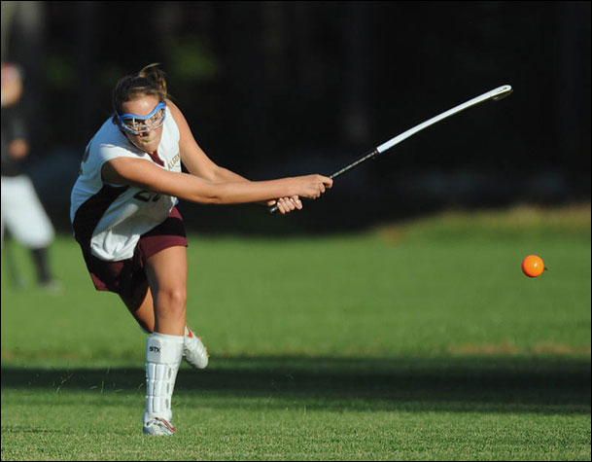

Explain the meaning of Newton’s 1st, 2nd and 3rd Laws and apply each law to a hockey hit.
_______________________________________________________________________________________________________________________________________________________________________________________________________________________________________________________________________________________________________________________________________________________________________________________________________________________________________________________________________________________________________________________________________________________________________________________________________________________________________________________________________________________________________________________________________________________________________________________________

Question 3 (6 marks)

How is velocity different to speed and why is instantaneous velocity usually a more useful measurement than mean velocity?
______________________________________________________________________________________________________________________________________________________________________________________________________________________________________________________________________________________________________________________________________________________________________________________________________________________________________________________________________________________________________________________________________________________________________________________________________________

Question 4 (8 marks)

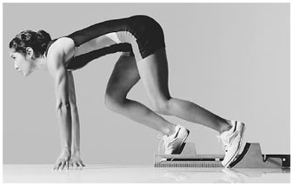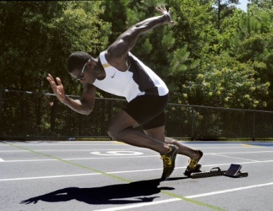

Photograph 1 Photograph 2

- In which photograph is the athlete more balanced? Explain why. (4 marks)
_______________________________________________________________________________________________________________________________________________________________________________________________________________________________________________________________________________________________________

- Mark and label the approximate location of the centre of gravity and line of gravity of the athlete on photograph 2. (2 marks)

- Which type of balance is displayed in each photograph? (2 marks)
______________________________________________________________________________________________________________________

Question 5 (8 marks)
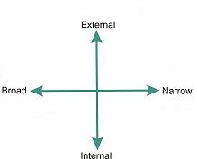

Diagram above: Nideffer’s Model of Attention

Nideffer’s model proposes that there are 4 different types of attentional focus. Discuss the characteristics of each type of attentional focus and provide a sporting example where each type of attentional focus is used.
____________________________________________________________________________________________________________________________________________________________________________________________________________________________________________________________________________________________________________________________________________________________________________________________________________________________________________________________________________________________________________________________________________________________________________________________________________________________________________________________________________________________________________________________________

Question 6 (6 marks)

Skilful coaches use a variety of cues to improve the performance of their players. Identify three different types of cues used by coaches and give an example of how each cue could be used to help a young player learn a new skill.
__________________________________________________________________________________________________________________________________________________________________________________________________________________________________________________________________________________________________________________________________________________________________ ______________________________________________________________________________________________________________________

Question 7 (6 marks)

Discuss the two main types of feedback and explain how each type can be used to improve performance.
__________________________________________________________________________________________________________________________________________________________________________________________________________________________________________________________________________________________________________________________________________________________________
_________________________________________________________________________________________________________________________________________________________________________________

Question 8 (5 marks)

The following comments were made by tennis champion Roger Federer after winning an important tennis match:
“I had moments out there where I really felt this is how I normally play on hard court – half volleys, passing shots, good serving, putting the pressure on, playing the wind, using it to my advantage. I definitely had moments during today where I thought ‘this is how I would like to play every time’. So it was a very nice feeling“

How do Federer’s comments indicate that he was in ‘the zone’ and how do you think this affected his performance?
______________________________________________________________________________________________________________________
_________________________________________________________________________________________________________________________________________________________________________________
___________________________________________________________
______________________________________________________________________________________________________________________

END OF SECTION TWO
SECTION THREE: EXTENDED ANSWER (30 MARKS)

There are four questions in this section. Attempt two questions.

Write your answers on the lined pages provided at the back of this booklet. Ensure that you clearly identify each answer.

Suggested working time for this section is 60 minutes.

Question 1 (15 marks)

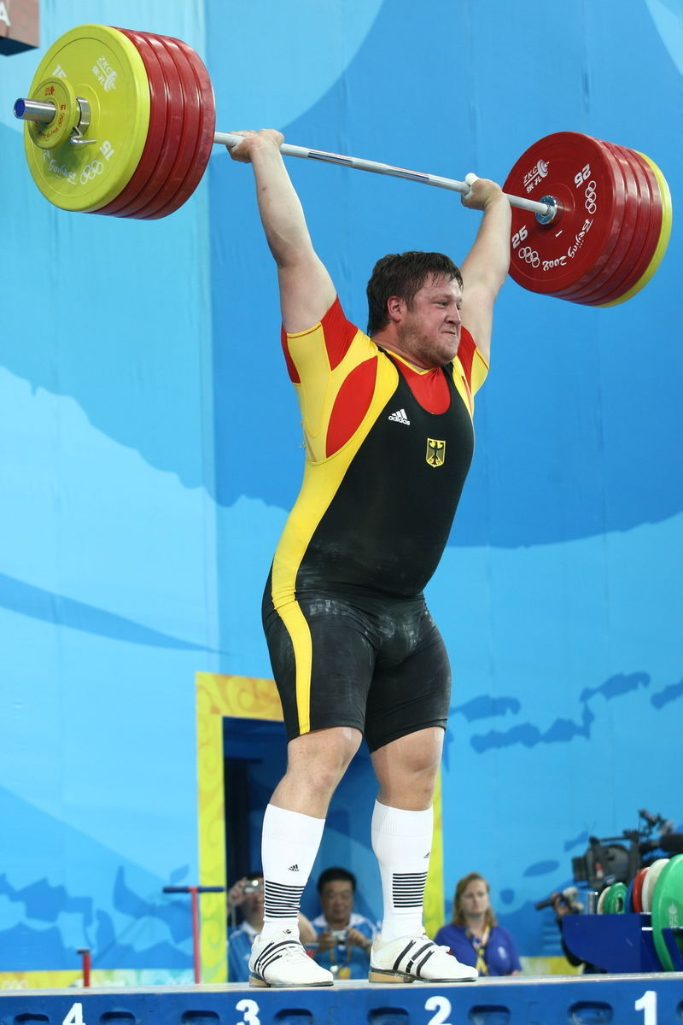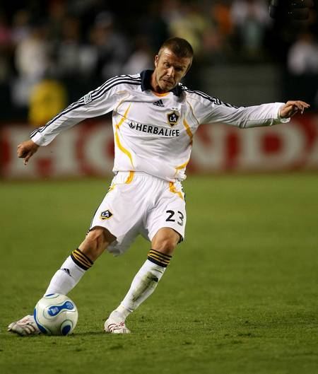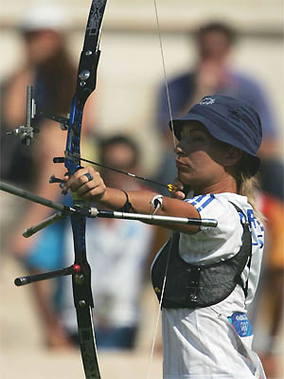

- Explain the meaning of the phrase ‘arousal regulation’ and discuss the different levels of arousal required for the three sports depicted above i.e. weightlifting, soccer and archery, with reference to the ‘Inverted U Hypothesis’. (11 marks)

- Select one of the sports depicted above i.e. weightlifting, soccer or archery and discuss two mental skills strategies that an athlete from that sport could use to regulate their arousal level. (4 marks)

and/or

Question 2 (15 marks)

You are the coach of a junior team (or junior player in an individual sport) in a sport of your choice. Your team (or player) has no previous experience in the sport.

- Identify and describe the phase of motor learning, according to the Fitts and Posner model, that your team (or player) is at and explain how you would use your knowledge of the characteristics of this phase of motor learning to develop the motor skills of your team (or player). (9 marks)

- Discuss why you would encourage the development of intrinsic motivation in your players (or player) and how you would use goal setting to facilitate this. (6 marks)

and/or

Question 3 (15 marks)

- Select three methods of classifying motor skills. Using examples, explain the meaning of each classification method. (9 marks)

- Choose one motor skill e.g. a baseball hit and discuss the phases of information processing that occur during performance of that skill. (6 marks)

and/or

Question 4 (15 marks)

- Using examples, explain the differences between linear, angular and general motion. In your answer, identify the most common type of motion and provide two reasons for this.
(9 marks)

- Discuss how the following factors influence the throwing of a ball for maximum distance:
  - angle of release
  - height of release
  - coordination of motion (6 marks)

End of Questions

Write your answers to Section Three on these lined pages.
Answers to Section 2 can be continued here if there was not enough room on the lines provided.
Ensure that answers are clearly identified/numbered
____________________________________________________________________________________________________________________________________________________________________________________________________________________________________________
_________________________________________________________________________________________________________________________________________________________________________________
_________________________________________________________________________________________________________________________________________________________________________________
_________________________________________________________________________________________________________________________________________________________________________________
_________________________________________________________________________________________________________________________________________________________________________________
_________________________________________________________________________________________________________________________________________________________________________________
_________________________________________________________________________________________________________________________________________________________________________________
_________________________________________________________________________________________________________________________________________________________________________________
_________________________________________________________________________________________________________________________________________________________________________________
_________________________________________________________________________________________________________________________________________________________________________________
_________________________________________________________________________________________________________________________________________________________________________________
_________________________________________________________________________________________________________________________________________________________________________________
_________________________________________________________________________________________________________________________________________________________________________________________________________________________________________________________________________________________________________________________________________________________________
______________________________________________________________________________________________________________________
____________________________________________________________________________________________________________________________________________________________________________________________________________________________________________
_________________________________________________________________________________________________________________________________________________________________________________
_________________________________________________________________________________________________________________________________________________________________________________
_________________________________________________________________________________________________________________________________________________________________________________
_________________________________________________________________________________________________________________________________________________________________________________
_________________________________________________________________________________________________________________________________________________________________________________
_________________________________________________________________________________________________________________________________________________________________________________
_________________________________________________________________________________________________________________________________________________________________________________
_________________________________________________________________________________________________________________________________________________________________________________
_________________________________________________________________________________________________________________________________________________________________________________
_________________________________________________________________________________________________________________________________________________________________________________
_________________________________________________________________________________________________________________________________________________________________________________
____________________________________________________________________________________________________________________________________________________________________________________________________________________________________________
_________________________________________________________________________________________________________________________________________________________________________________
____________________________________________________________________________________________________________________________________________________________________________________________________________________________________________
_________________________________________________________________________________________________________________________________________________________________________________
_________________________________________________________________________________________________________________________________________________________________________________
_________________________________________________________________________________________________________________________________________________________________________________
_________________________________________________________________________________________________________________________________________________________________________________
_________________________________________________________________________________________________________________________________________________________________________________
_________________________________________________________________________________________________________________________________________________________________________________
_________________________________________________________________________________________________________________________________________________________________________________
_________________________________________________________________________________________________________________________________________________________________________________
_________________________________________________________________________________________________________________________________________________________________________________
_________________________________________________________________________________________________________________________________________________________________________________
_________________________________________________________________________________________________________________________________________________________________________________
_________________________________________________________________________________________________________________________________________________________________________________________________________________________________________________________________________________________________________________________________________________________________
______________________________________________________________________________________________________________________
____________________________________________________________________________________________________________________________________________________________________________________________________________________________________________
_________________________________________________________________________________________________________________________________________________________________________________
_________________________________________________________________________________________________________________________________________________________________________________
_________________________________________________________________________________________________________________________________________________________________________________
_________________________________________________________________________________________________________________________________________________________________________________
_________________________________________________________________________________________________________________________________________________________________________________
_________________________________________________________________________________________________________________________________________________________________________________
_________________________________________________________________________________________________________________________________________________________________________________
_________________________________________________________________________________________________________________________________________________________________________________
_________________________________________________________________________________________________________________________________________________________________________________
_________________________________________________________________________________________________________________________________________________________________________________
_________________________________________________________________________________________________________________________________________________________________________________
____________________________________________________________________________________________________________________________________________________________________________________________________________________________________________
_________________________________________________________________________________________________________________________________________________________________________________
______________________________________________________________________________________________________________________
____________________________________________________________________________________________________________________________________________________________________________________________________________________________________________
_________________________________________________________________________________________________________________________________________________________________________________
_________________________________________________________________________________________________________________________________________________________________________________
_________________________________________________________________________________________________________________________________________________________________________________
_________________________________________________________________________________________________________________________________________________________________________________
_________________________________________________________________________________________________________________________________________________________________________________
_________________________________________________________________________________________________________________________________________________________________________________
_________________________________________________________________________________________________________________________________________________________________________________
_________________________________________________________________________________________________________________________________________________________________________________
_________________________________________________________________________________________________________________________________________________________________________________
_________________________________________________________________________________________________________________________________________________________________________________
_______________________________________________________________________________________________________________________________________________________________________________________________________________________________________________________________________________________________________
_________________________________________________________________________________________________________________________________________________________________________________
_________________________________________________________________________________________________________________________________________________________________________________
______________________________________________________________________________________________________________________
____________________________________________________________________________________________________________________________________________________________________________________________________________________________________________
_________________________________________________________________________________________________________________________________________________________________________________
_________________________________________________________________________________________________________________________________________________________________________________
_________________________________________________________________________________________________________________________________________________________________________________
_________________________________________________________________________________________________________________________________________________________________________________
_________________________________________________________________________________________________________________________________________________________________________________
_________________________________________________________________________________________________________________________________________________________________________________
_________________________________________________________________________________________________________________________________________________________________________________
_________________________________________________________________________________________________________________________________________________________________________________
_________________________________________________________________________________________________________________________________________________________________________________
_________________________________________________________________________________________________________________________________________________________________________________
__________________________________________________________________________________________________________________________________________________________________________________________________________________________________________________________________________________________________________________________________________________________________
_________________________________________________________________________________________________________________________________________________________________________________
______________________________________________________________________________________________________________________
____________________________________________________________________________________________________________________________________________________________________________________________________________________________________________
_________________________________________________________________________________________________________________________________________________________________________________
_________________________________________________________________________________________________________________________________________________________________________________
_________________________________________________________________________________________________________________________________________________________________________________
_________________________________________________________________________________________________________________________________________________________________________________
_________________________________________________________________________________________________________________________________________________________________________________
_________________________________________________________________________________________________________________________________________________________________________________
_________________________________________________________________________________________________________________________________________________________________________________
_________________________________________________________________________________________________________________________________________________________________________________
_________________________________________________________________________________________________________________________________________________________________________________
_________________________________________________________________________________________________________________________________________________________________________________
______________________________________________________________________________________________________________________

This blank space has been provided for additional workings.

Marking Key

SECTION ONE: MULTIPLE CHOICE (20 marks)

Question Number | Correct Answer
1. | d
2. | b
3. | a
4. | d
5. | b
6. | a
7. | a
8. | c
9. | d
10. | a
11. | d
12. | b
13. | c
14. | c
15. | b
16. | b
17. | c
18. | d
19. | b
20. | a

SECTION TWO: SHORT ANSWER (50 MARKS)

Question 1 (5 marks)

Using examples, compare and contrast trait and state anxiety.

 | 1 mark | 2 marks
Compare | Understands that both trait and state anxiety relate to anxiety and at least one of the following points regarding anxiety: negative emotional state, usually harmful to performance, a characteristic of anxiety such as worry, nervousness
Trait anxiety | States that trait anxiety relates to a persons predisposition to perceive situations as threatening or provides valid example e.g. a player feeling nervous before every match | States that trait anxiety relates to a persons predisposition to perceive situations as threatening and provides valid example
State anxiety | States that state anxiety relates to the pressure of a specific situation independent of a persons personality (or similar) or provides valid example e.g. a player feeling nervous before a grand final | States that state anxiety relates to the pressure of a specific situation independent of a persons personality (or similar) and provides valid example

Question 2 (6 marks)

Explain the meaning of Newton’s 1st, 2nd and 3rd Laws and apply each law to a hockey hit.

 | 1 mark | 2 marks
Newton’s 1st Law | Understands that an object remains at rest or in a constant state of motion unless acted upon by a force or accurately applies law to a hockey hit e.g. the ball will stay motionless unless the stick strikes it | Understands that an object remains at rest or in a constant state of motion unless acted upon by a force and accurately applies law to a hockey hit
Newton’s 2nd Law | Understands that the acceleration of an object is proportional to the force acting upon it (or f=ma) or accurately applies law to a hockey hit e.g. | Understands that the acceleration of an object is proportional to the force acting upon it and inversely proportional to its mass and accurately applies law to a hockey hit
Newton’s 3rd Law | Understands that for every action there is an equal and opposite reaction or accurately applies law to a hockey hit e.g. the stick exerts a force on the ball and the ball exerts an equal and opposite force on the stick | Understands that for every action there is an equal and opposite reaction and accurately applies law to a hockey hit

Question 3 (6 marks)

How is velocity different to speed and why is instantaneous velocity usually a more useful measurement than mean velocity?

 | 1 mark | 2 marks
Velocity | Displacement divided by time or takes into account direction | As for 1 mark and explains that displacement is distance in a straight line between the starting and finishing point
Speed | Distance divided by time or doesn’t take into account direction
Instantaneous measurement | Measured at one specific point of a movement or provides valid reason e.g. mean measure can be zero/meaningless ( i.e. if starting point and finishing point is the same) or the velocity at release/take-off/contact is usually the most important factor | Measured at one specific point of a movement or provides valid reason
Mean measurement | Measured over entire movement

Question 4 (8 marks)

- In which photograph is the athlete more balanced? Explain why. (4 marks)

Identifies Photograph 1 | 1 mark
Accurately discusses line of gravity | 1 mark
Accurately discusses height of centre of gravity | 1 mark
Accurately discusses width/size/area of base of support | 1 mark

- Mark and label the approximate location of the centre of gravity and line of gravity of the athlete on photograph 2. (2 marks)

Centre of gravity correctly located on photograph 2 | 1 mark
Line of gravity extends vertically downwards from the centre of gravity on photograph 2 | 1 mark

- Which type of balance is displayed in each photograph? (2 marks)

Photograph 1 – static balance | 1 mark
Photograph 2 – dynamic balance | 1 mark

Question 5 (8 marks)

Nideffer’s model proposes that there are 4 different types of attentional focus. Discuss the characteristics of each type of attentional focus and provide a sporting example where each type of attentional focus is used.

 | 1 mark | 2 marks
Broad-external | Accurately discusses one characteristic of type e.g. attending to many cues in external environment, peripheral awareness, needed for team sports or provides valid example e.g. soccer midfielder | Accurately discusses two characteristics of type and provides valid example
Broad-internal | Accurately discusses one characteristic of type e.g. attending to many thoughts/options internally, analysing a situation, strategic planning or provides valid example e.g. a footballer thinking about coaching instructions before a game, a basketball coach planning game strategies | Accurately discusses two characteristics of type and provides valid example
Narrow-external | Accurately discusses one characteristic of type e.g. attending to one main cue in external environment, focused targeting, blocking out irrelevant cues/distractions or provides valid example e.g. archer focusing on target, free throw shooter in basketball | Accurately discusses two characteristics of type and provides valid example
Narrow-internal | Accurately discusses one characteristic of type e.g. attending to one main thought/idea/tactic internally, kinaesthetic awareness or provides valid example e.g. a footballer focusing one main coaching instruction, a tennis player meditating before a game, a sprinter focusing their stretching on one muscle at a time | Accurately discusses two characteristics of type and provides valid example

Question 6 (6 marks)

Skilful coaches use a variety of cues to improve the performance of their players. Identify three different types of cues used by coaches and give an example of how each cue could be used to help a young player learn a new skill.

 | 1 mark | 2 marks
Visual cues | Correctly identifies cue or provides appropriate example e.g. demonstrating skill, showing video | Correctly identifies cue and provides appropriate example for young player learning a skill e.g. demonstrating how to kick a football to a junior
Verbal cues | Correctly identifies cue or provides appropriate example e.g. stating the teaching points for a skill | Correctly identifies cue and provides appropriate example for young player learning a skill e.g. states a few main teaching points so the young player isn’t overloaded with information
Proprioceptive cues | Correctly identifies cue or provides appropriate example e.g. coach moves the player’s arm through the action | Correctly identifies cue and provides appropriate example for young player learning a skill e.g. coach moves the young player’s arm through the bowling action so they can feel what the movement is like

Question 7 (6 marks)

Discuss the two main types of feedback and explain how each type can be used to improve performance.

 | 1 mark | 2 marks | 3 marks
Extrinsic (augmented) feedback | Feedback type identified and understands that it comes from an external source | As for 1 mark and accurately explains how it can be used to improve performance e.g. point out errors, positive reinforcement | As for 2 marks and discusses both error correction and positive reinforcement in explanation
Intrinsic (inherent) feedback | Feedback type identified and understands that it comes from an internal source | As for 1 mark and accurately explains how it can be used to improve performance e.g. positive reinforcement of a successful movement, negative reinforcement of an unsuccessful movement | As for 2 marks and discusses both positive reinforcement of a successful movement and negative reinforcement of an unsuccessful movement

Question 8 (5 marks)

The following comments were made by tennis champion Roger Federer after winning an important tennis match:
“I had moments out there where I really felt this is how I normally play on hard court – half volleys, passing shots, good serving, putting the pressure on, playing the wind, using it to my advantage. I definitely had moments during today where I thought ‘this is how I would like to play every time’. So it was a very nice feeling“

How do Federer’s comments indicate that he was in ‘the zone’ and how do you think this affected his performance?

 | 1 mark | 2 marks | 3 marks
In the zone | Makes reference to comments that relate to technical or strategic or psychological aspects of being in the zone | Makes reference to comments that relate to two of: technical or strategic or psychological aspects of being in the zone | Makes reference to comments that relate to all three of: technical, strategic and psychological aspects of being in the zone
Effect on performance | States that Federer’s performance was enhanced by being in the zone (or similar) or makes reference to Federer feeling good about his play/feeling confident | States that Federer’s performance was enhanced by being in the zone (or similar) due to feeling good about his play/feeling confident

SECTION THREE: EXTENDED ANSWER (30 MARKS)

Mark the first two extended answer questions attempted

Question 1

- Explain the meaning of the phrase ‘arousal regulation’ and discuss the different levels of arousal required for the three sports depicted above i.e. weightlifting, soccer and archery, with reference to the ‘Inverted U Hypothesis’. (11 marks)

 | 1 mark | 2 marks | 3 marks
Arousal regulation | Explains the meaning of arousal e.g. readiness, psychological and physiological stimulation or regulation e.g. to control or adjust the level of | Explains the meaning of arousal and regulation
Weight-  lifting | High level of arousal required or accurate reason why e.g. to recruit maximum number of muscle fibres, minimal need for strategic thought/cue recognition | High level of arousal required and accurate reason why
Soccer | Medium level of arousal required or accurate reason why e.g. broad/external attentional focus, strategic thinking, intense exercise | Medium level of arousal required and accurate reason why
Archery | Low level of arousal required or accurate reason why e.g. steady hands/no shaking needed, sense of ‘feel’ | Low level of arousal required and accurate reason why
Inverted U Hypothesis | 1 of the following:  Understands that the hypothesis involves 2 components: arousal and performance or understands that the athlete can be under, over or optimally aroused or understands that the optimal level of arousal shifts depending on the age or skill level or type of activity | As for 1 mark but understands two points | As for 1 mark but understands all three points

- Select one of the sports depicted above i.e. weightlifting, soccer or archery and discuss two mental skills strategies that an athlete from that sport could use to regulate their arousal level. (4 marks)

 | 1 mark | 2 marks
Mental skill strategy 1 | Identifies a valid mental skills strategy e.g. relaxation, self-imagery, self-talk, goal setting, performance routines | As for 1 mark and accurately discusses how the strategy could be used to regulate arousal for one of the sports
Mental skill strategy 2 | Identifies a second valid mental skills strategy e.g. relaxation, self-imagery, self-talk, goal setting, performance routines | As for 1 mark and accurately discusses how the second strategy could be used to regulate arousal for one of the sports

Question 2 (15 marks)

You are the coach of a junior team (or junior player in an individual sport) in a sport of your choice. Your team (or player) has no previous experience in the sport.

- Identify and describe the phase of motor learning, according to the Fitts and Posner model, that your team (or player) is at and explain how you would use your knowledge of the characteristics of this phase of motor learning to develop the motor skills of your team (or player). (9 marks)

 | 1 mark | 2 marks | 3 marks
Identifies | Identifies cognitive stage
Describes | One of the following: explains meaning of cognitive stage i.e. need to gain an understanding of the task to be learned or heavily reliant on the coach or large number of errors made or errors large in magnitude/large variability in performance | As for 1 mark but understands two points | As for 1 mark but understands three or more points
Motor skill development | Extrinsic feedback is very important or explains need for at least one of the following types of feedback: terminal, concurrent, verbal, reinforcement, Knowledge of Performance, motivation | Extrinsic feedback is very important and explains need for at least two of the types of feedback stated for 1 mark
Motor skill development | One valid consideration explained e.g. simplify skills, focus on fundamental skills for sport, modified equipment/rules, other | Two valid considerations explained | Three valid considerations explained

- Discuss why you would encourage the development of intrinsic motivation in your players (or player) and how you would use goal setting to facilitate this. (6 marks)

 | 1 mark | 2 marks | 3 marks
Why – intrinsic motivation | One of the following discussed: intrinsic motivation associated with persistence with the sport; explains the meaning of intrinsic motivation i.e. fun, satisfaction; accurately contrasts with extrinsic motivation; other valid point | As for 1 mark but understands two points | As for 1 mark but understands all three points
How – goal setting | One of the following discussed: specific not general; measurable; realistic/achievable/moderately difficult; time-bound; related to skill development; process based (not outcome oriented); other valid point | As for 1 mark but understands at least two points | As for 1 mark but understands at least four points

Question 3 (15 marks)

- Select three methods of classifying motor skills. Using examples, explain the meaning of each classification method. (9 marks)

 | 1 mark | 2 marks | 3 marks
Method 1 | Valid method identified e.g. open/closed, simple/complex, gross/fine, discrete/ serial/continuous | As for one mark and accurately explains the meaning of the classification method or provides a valid example for each part of the classification method e.g. examples for open & closed | As for one mark and accurately explains the meaning of the classification method and provides a valid example for each part of the classification method e.g. open & closed
Method 2 | As above | As above | As above
Method 3 | As above | As above | As above

- Choose one motor skill e.g. a baseball hit and discuss the phases of information processing that occur during performance of that skill. (6 marks)

 | 1 mark | 2 marks
Identification of stimuli or input | Accurately identifies and discusses phase
Response identification or decision-making | Accurately identifies and discusses phase
Response or output | Accurately identifies and discusses phase
Feedback | Accurately identifies and discusses phase
Motor skill | Accurately applies 2 or 3 phases to chosen skill | Accurately applies all 4 phases to chosen skill

Question 4 (15 marks)

- Using examples, explain the differences between linear, angular and general motion. In your answer, identify the most common type of motion and provide two reasons for this.
(9 marks)

 | 1 mark | 2 marks
Linear motion | Understands that linear motion involves movement in a straight (or curvilinear) line | As for 1 mark and provides valid example e.g. trunk when cycling, skater gliding
Angular motion | Understands that angular motion involves rotation about an axis | As for 1 mark and provides valid example e.g. ice skater spinning, hip action whilst running/cycling
General motion | Understands that general motion is where angular motion produces linear motion | As for 1 mark and provides valid example e.g. running, cycling
Most common | States that general motion is the most common type
Reasons why | Provides one valid reason why e.g. most joints are only capable of angular motion, most movements involve linear displacement in order for the purpose of the movement to be fulfilled | Provides two valid reasons why e.g. most joints are only capable of angular motion, most movements involve linear displacement in order for the purpose of the movement to be fulfilled

- Discuss how the following factors influence the throwing of a ball for maximum distance:
  - angle of release
  - height of release
  - coordination of motion (6 marks)

 | 1 mark | 2 marks | 3 marks
Angle of release | 45 degree angle is optimal if everything is equal
Height of release | Optimal angle is less than 45 degrees if the height of release is above the landing height | As for 1 mark and optimal angle is more than 45 degrees if the height of release is below the landing height
Coordination of motion | Discusses one of:  sequential movement/summation of velocity produces greater distance; larger/proximal segments move first (or smaller/distal segments move last); next segment moves when previous segment reaches maximum velocity | As for one mark but discusses two points | As for one mark but discusses three points

